**Crowd Simulation: Queue-up Behavior**

MS Project Report

Zhicheng Chen

University of Nebraska at Omaha

Advisor: Brian Ricks  
January 25, 2019

**Abstract**

Understanding complicated crowd behaviors is essential to urban designers and architects. However, grouping a large amount of people to do experiment is dangerous and unrealistic. In order to do experiments, researchers are required to design and create an application which could correctly represent crowd behavior. This project report describes an implementation called Queue-up Crowd Simulation that aim at creating realistic, unique and dynamic crowds by taking agents’ data as input and outputting the results in animation form.

**1 Introduction**

The increasing proportion of people living in urban areas brings new challenges to urban planning and architecture. Crowd simulation plays an important role in addressing these challenges. With the help of crowd simulation techniques, urban designers and architects could determine the evacuation time of a massive crowd, predict the behavior of a crowd flow inside of a building or prevent overcrowding during certain events. In order to create realistic and trustworthy crowd simulation results, I designed a sophisticated crowd simulation algorithm that allows agents to achieve complex features. The features I implemented are obtained from data collections and direct observations from video records in real-life events.

First, I discuss about related previous approaches. Then, I present important components of this application which use the open source library Recast & Detour. Then I discuss observations and collections of real-life video records that are essential to understand the output produced by QueueBehaviorApp. Also, I present details about the scene initialization and agent initialization. Then I talk about the goal scenario observed and abstracted from source videos, the implementations detail and strategy of simulation results evaluation. Finally, I conclude with future work discussion.

**2 Previous Work**

There are several existing crowd simulation approaches. Some approaches aim at simulating natural human behaviors while agents encounter specific condition, some approaches allow agents implemented certain strategies to make decision.

Mirza Waqar[2] designed agent as ellipses that have a sense of the environment and plan their own path ahead of time to avoid agent collisions. Unfortunately, the output of this kind of simulation lacks realism and flexibility. Since it does not involve complex behaviors such as allowing agents to move in and out of different group or queues based on agent’s desire, agents who have planned a path ahead of time might end up a situation such as an unnatural long waiting line in the scene where several shorter lines exist. However, in reality, people do not just stay in waiting line once they choose it; they might need to change lines if there is a better option.

Other simulation approaches have achieved complicated behaviors. Julio Godoy [6] provided a dynamic agent base approach that allowed agents in a scene to have distinct goals and plan their own movements and collision avoidance ability. Interactions among each agent are “polite” and natural after agents learned optimal strategy in the given simulated environment. Carmine [3] extended state-of-art predictive approaches with social awareness, prediction and social collision avoidance to achieve the prediction in social path following behavior. Social awareness is signaling agents that are approaching each other, then agents adjust their behavior and direction for future social interaction to improve the realism.

In the simulation, simply allowing the agents to have interaction, repulsive forces and given priority are not enough. In order to simulate social interactions among agents in the crowd, Walk Along Steering [4] developed the Walk Along Steering algorithm that allows agents in small groups to have six social steering behaviors that makes agents’ movement and reaction smoothly and naturally. Based on a three- layer architecture controlling motion of IVAs designed by Reynolds [1], agents could achieve patterns like following, avoidance, waiting and approaching. To allow the crowd to have more dynamic social behaviors, Sai-Keung’s [5] approach presents a crowd simulation that involves behaviors agents that are more interactive. In the simulation, two or more agents are required to perform actions simultaneously to finish certain tasks, agents are divided into two categories: workers and pedestrians. Tasks can be assigned to worker agents; workers will cooperate with each other and create complicated behaviors by decomposing a complex task into numbers of simple task.

Contribution:

* A realistic and dynamic crowd algorithm with agents which could form waiting lines and each agent orderly pass through simulated security checking spots one by one.
* Agents in the scene could dynamically move in and out of different waiting line to move to the most desired waiting line.
* Flexible pair walking algorithm allows agents in pair relationship dynamically stay side by side while walking in the scene.

**3 Observations from Video Records**

In order to understand how a crowd moved, I study and analyze of recorded crowd videos at CenturyLink on different entrances during events such as concerts and a Disney on Ice Event. Then I abstract common behaviors such as gathering, walking, forming waiting lines and passing security processes. Following are specific behaviors I achieved:

* Pair walking, pair line up.
* Queue up behavior.
* Form waiting lines.
* People switch from a long line to shorter one.

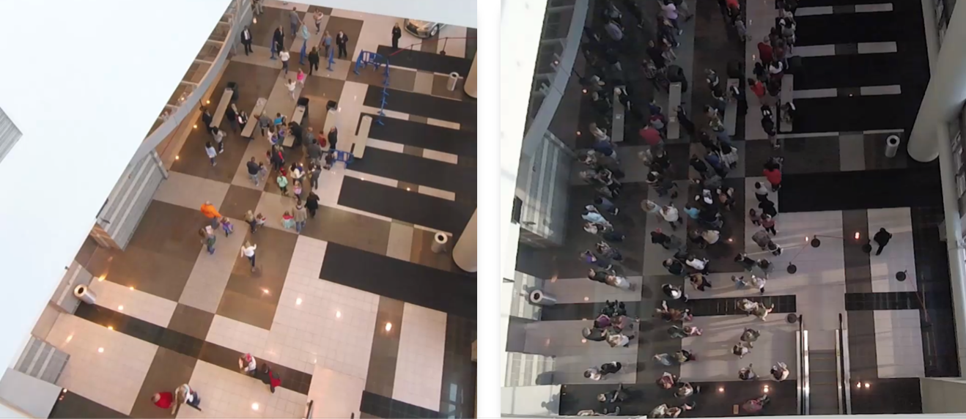

**3.1 Pair Walking**

Normally, people attend events with their friends or family, thus people in the crowd are divided into numbers of small groups. Because people know each other and have conversations while they are walking, people in a small group are more likely to stay side by side. If one of the people in the group is left behind, people in front will stop somewhere and wait until his/her partner catches up, or if people realize themselves are left behind their partner, they will speed up to catch up is partner. Based on the videos, this behavior happens a lot. For example, people who finished the security check will stand at somewhere in front and wait for his/her partner.

**3.2 Queue up Behavior**

When a waiting line is formed, people simply queue up and slowly move forward in the line. Because people might walk with their friends, they might form waiting line that each row could have one or two people. Based on videos, waiting lines could have different length, and I found out people in the long waiting line will change to the shorter line or people will directly change direction and walk to the new gate if they find out there has a new empty gate. However, for some people, they might be less interested in moving to the shorter line and just stay at their original line.

**3.3 Security Checking Behavior**

For people who reach the security gates, they have two security processes to finish before entering the building. For the first process, security faculties check the ticket and bag (if someone carries bag to the event). For people just bringing the ticket, people show the ticket to the checker, then they could quickly pass through the first gate. For people who carry bags, security faculty need to take a few seconds to check people’s bag. Thus, people who carries bag stay more time on the first gate. For the second process, security faculty uses handheld body scanner to scan people one by one. Because everyone takes almost the same process, the time difference among people need to finish the second process is more consistent than the first process.

Based on those videos, the scenes contain two lines of security gates. If the number of people pass the first gate line is large enough, the room between lines is easy to get full. When the room is full, even people finish the first checking process, they still need to wait until there have space to let them move forward.

**4 Resources**

This application uses an open source library Java Port of Recast & Detour navigation mesh toolset [7].

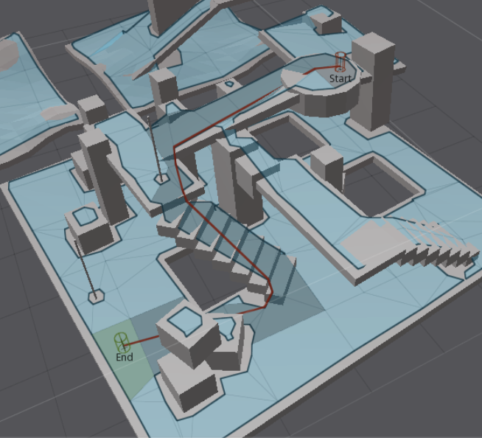

**Recast**

Recast is a state-of-the-art navigation mesh construction toolset for games. Recast is an open source library that could automatically provide you a mesh at any level geometry quickly; Recast could also be customized to achieve user’s specific purpose.

**Detour**

Detour is a spatial reasoning toolkit which accompanies with Recast to offer a simple static navigation mesh. DetourCrowd is a crowd management module offers features for agents handling and behavior customization. Detour allows a user to create lots of agents and move agents in a navigation mesh. Detour also allows user to create customized behaviors that determines agent’s how to move and react at a low level.

**4 Foundation architecture and Scenario**

In this project, I developed a crowd simulation application which aims at creating realistic, dynamic and accurate crowd. To achieve this goal, I used an open source state of art navigation mesh construction toolset called Recastnavigation to achieve static avoidance and shortest path calculation. I also utilized a path-finding and spatial reasoning toolkit Detour to achieve dynamic avoidance among agents in the path and to completed calculation of each frame of the simulation [3]. Using these open source platforms, I built the lower level of my approach – QueueBehaviorApp.

A crowd forms when a large amount of people gathers in a limited space. Simulating the crowd as a single unit might help understand its flow movement. However, each person in a crowd is independent. In order to achieve this feature, I divided the crowd into groups that contains 2 people or individuals so the behavior of the crowd can be more realistic. In a group, people that know each other might walk together. Previous researcher Reynolds [1] proposed a steering approach known as Leader Following (LF). This approach also involves pair agents where the “follower” agent follows the leader and stays to its side. The disadvantage of this approach is that the leader agent does not wait for its follower agent if the distance between these two agents is too large, which is not realistic.

Scenario: Single agents or pair agents are randomly generated from the virtual entrance; each agent is initialized with a default start position and end position, and they will walk from start to end position. However, before agents reaching their destination, every agent has to finish two security checks first. (People did ticket checking and security check during the concert event). Thus, every agent needs to stop near the security gate to simulate the security process. Since the new agents are generating and security process takes time, the number of agents in the scene increase dramatically and a crowd form. However, instead of generating a massive chaotic crowd, agents in the crowd will orderly queue up and form several waiting lines, and each agent in line will do the security check one by one. After finishing the security check, agents will move to their default end position and depart.

**5 Environment Implementation and Setup**

**5.1 Input Data Initialization**

Input file allows us to determine the basic scene information such as agent id, agent start time, start position, end position and behavior mode. Instead of directly applying data from the real-life video, I need to manually generate agent data based on features I observed from the video. For example, I defined agents in pair relationship by letting agents have the same enter time, start position and end position.

In order to achieve more crowd features, I designed input data base on the following patterns: Agent id, enter time, start position, end position, behaved mode. Each agent has its unique id number. Agent’s enter time determines when agent will walk into the scene.

Start position determines where agent will appear. End position determines where agent will exit, it also determines agent’s walking direction. Enter time, start position and end position determine agent’s relationship. Agent’s behavior mode demonstrates agent’s behavior:

* Queue – means agent will queue up to form line.
* None – means agent will simply walk from start position to end position.

Below is the data input sample:

30,3656,-60.255486,0.31802097,-5.320471,44.077248,0.318020731,1.1289825,queue 31,3661,-59.755486,0.31802097,-4.820471,44.577248,0.318020731,1.6289825,queue 32,4734,-61.710487,0.31802097,11.044155,44.371113,0.318020731,6.9663258,queue

Blue is agent id; each agent has its unique id; green is agent’s enter time; 3656 means agent enters the scene at 3656 million second; orange is the start position (x coordinate, z coordinate, y coordinate); red is the end position (x coordinate, z coordinate, y coordinate); purple is agent’s behavior mode.

In the simulation, agents who stand next to their corresponding gate are representing security faculty in the real-life video. Since our video are mostly recorded on a hall that only allows crowd walking from one place to another place, I decided to define agents’ start position and end position within this limited range to simulate the hall environment. What’s more, agent’s walking direction determines the expand direction of waiting line. For example, agent walking from left to right, when it reaches the tail of waiting line, it lines up at the tail, then the waiting line grow from right to left.

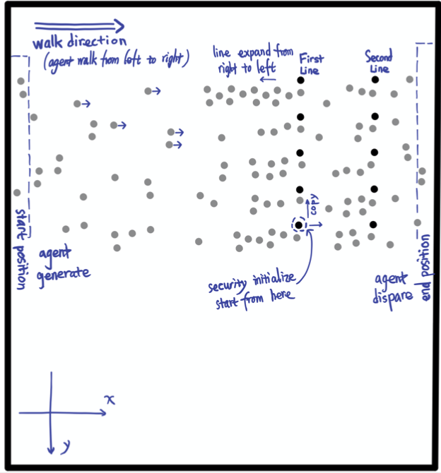

Here is a demo to help us better understand how to determine range of start position, end position and security gate lines.

Each circle represents an agent, agents in black are security faculty, agents in grey are normal agents. Faculty agent are specifically initialized, and they will stay at the same position during the simulation. Agents walk in from the rectangle on the left called start position and walk out of scene on rectangle on the right called end position. Without security gates, all normal agents simply walk from start position to the end position. However, in this case, agents will do security check and queue up.

**5.2 Environment Initialization**

Before achieving the complicated crowd behavior features such as pair walking, queuing up and form single/pair waiting lines, I need to initialize environment for agents so that they could perform security check. Before reaching the end position, every agent is required to pass through two positions to simulate security checks. Based on the real-life video samples I recorded during events, people have two checking process to finish before they enter the event, one is the ticket and bag checking, another one is body detector scanning. Having the input data is not enough, to make agent move naturally, I need more factors both in environment and agent itself.

At the beginning of the simulation, environment is initialized based on the input data that I mentioned above. Below I use an image of mock demo and several lines of code to demonstrate simulation result.

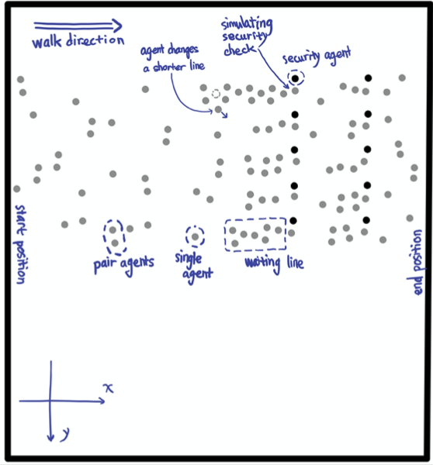

The code below are always runs at the beginning of the simulation.

initGates();

initAgentCheckTime();

initAgentGateOption();

initFriendRelationship();

initAgentsAnxiety();

Methods above cover all the initializations required in the simulation. Description below shows more about details of the initialization:

* **initGates** – In this scene, 10 checking gates are created and divided into two gate lines to represent two checking processes. Then 10 faculty agents are initialized and represent security faculties standing next to the gates. All security faculties will stand next to its own checking spot during the simulation.
* **initAgentCheckTime** – Each people have two processes to finish before entering the building, one is ticketing and bag checking, another one is body checking. Based on the observation, at the first gate, people carrying bag costs more checking time than people who just bring the ticket. However, the amount of time people spent in second gate is evener. Thus, in the simulation, each agent is randomly assigned two values to represent the amount of time they need to spend to finish both security checks. For the value that represents ticket/bag checking time, because the people carry bag are randomly appear and the number of them is relatively smaller than the number of people who don’t, the initialization of agents’ first gate checking time follows the corresponding pattern. However, for the value that represents the second gate checking time, since everyone has the same checking process, the values among each agent are more consistent.
* **initAgentGateOption** – In this simulation, agents are randomly generated on the one side of the scene. Then, based on each agent’s current position, they choose the closest gate to go and move forward.
* **initFrienddRelationship** – Every agent is whether in individual status or pair status. Based on the input data, agents that have the close enter time, start position and end position are set paired status and stay walking side by side. Each agent in pair plays different role, one is leader, another one is follower. Otherwise, agents are in individual status, which means they are neither leader nor follower.
* **initAgentsAnxiety** – In real life, people at tail of a waiting line might not be satisfied with the length of their own line and then they will seek opportunity to switch to the other shorter line. To achieve this behavior feature, each agent could make line change decision based on their anxiety degree. The agent’s anxiety degree updates based on the its current position in waiting line. However, not every people in the line is seeking the opportunity to switch to the shorter line, the variety of anxiety degree among each agent follows certain pattern. The agent with high anxiety is only the small proportion of all agents in the scene.

**5.3 Appearance Feature of Upcoming Agents**

In the simulation, in order to create a realistic crowd, I intensively control the flow of crowd and let it follows certain pattern. At the beginning of the simulation, the number of agents is relatively small, but when the simulation continues, the number of agents appear in the scene start to increase and then reaches the maximum. After that, the number of upcoming agents slowly decrease.

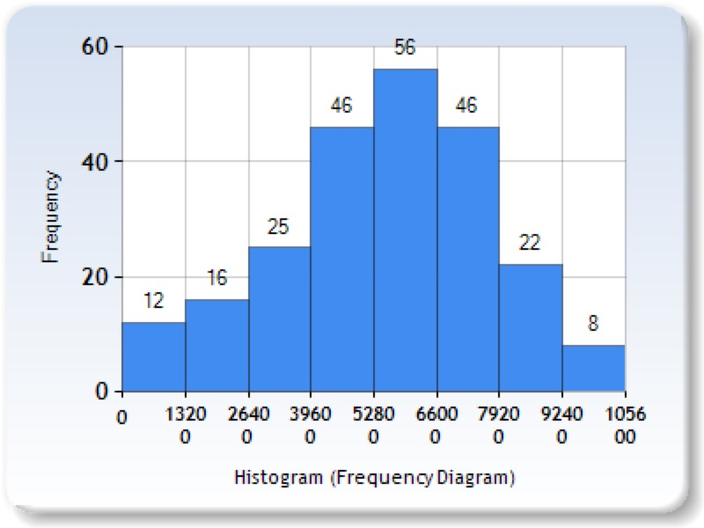

Charts above roughly illustrate the number of new agents appear every 1320 million seconds. The bar table shows the change of number of new coming agents during the simulation. During time range from 5280 to 6600 million seconds, the number of new coming agents reaches the maximum.

**6 Agent Behavior Implementation**

**6.1 Pair Walk Behavior**

In the real-life video, people in group are talking to each other while they are walking. To maintain this status, they need to stay side by side and sometimes they need to slightly adjust their speed to stay in pair. In order to achieve the natural pair walking pattern, I let agents in pairs to be followers or leaders. In the pair, leader is the one leads them to their shared destination; followers always adjust its speed to catch up its leader. However, only changing the speed of the follower is not enough, leader also needs to adjust its speed to wait or catch its follower. For example, in the simulation, if the leader finished security the check first, instead of directly moving to the next destination, the leader will stop somewhere in front and wait until its follower finish the check.

How to Achieve Pair Walking?

Agents in pair adjust theirs moving speed based on angle of two vectors: one is from leader’s current position to leader’s current destination. Another one is from leader’s current position to its follower’s current position. By utilizing the law of cosines, the angel between these two vectors is calculated.

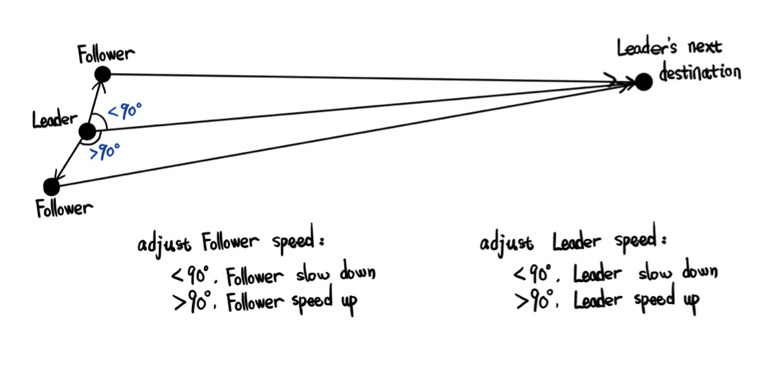

Bases on the value of angle, agent’s speed has three states:

* When the degree is 90: the follower is exactly left or right side of the its leader. The follower agent doesn’t need to change it’s moving speed.
* When the degree is less than 90, it means the follower is in front of its leader, the follower starts to slow down and the leader starts to speed up.
* When the degree is larger than 90, it means the follower is left behind by its leader, the follower starts to speed up and the leader starts to slow down.

However, knowing the angle between two vectors is not enough to create the natural speed adjustment. Because agents have to queue up or pass through the security checking process, the current destination of the leader’s agent might change. The modification of the current destination might affect the value of angle I mentioned above. Thus, in order to maintain the correct current destination, leader agent could update and set the next destination after agent has reach the current destination.

**6.2 Queue up Behavior**

In order to enter the event, people need to do security check, they stop at the security gate for a few seconds. However, the upcoming people continue moving to security gates, and people who wait behind will form waiting lines. To simulate the queue up behavior, each agent to have the following states:

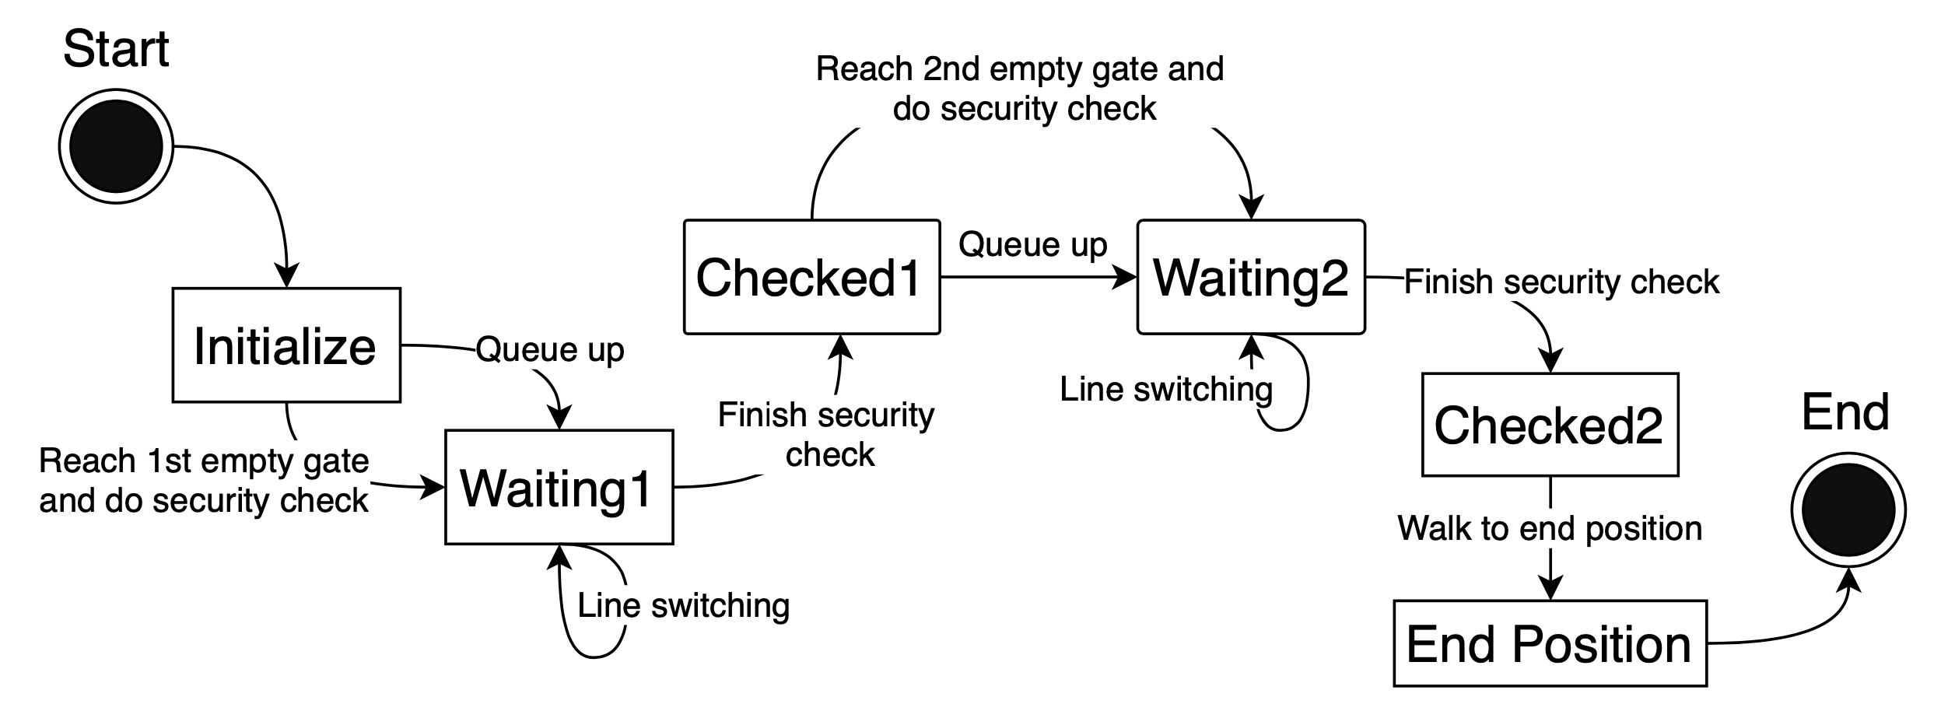

Image: queue_up_state_diagram

State diagram figure_state shows sequence of behaviors each agent in process of security check. It illustrates the executions of queue up behavior and security checking processes that change the agent’s states.

To simulate this queue up behavior, I allow each agent to have the following status:

* Waiting1 – agent lined up before the first gate line.
* Checked1 – agent finished the first security check.
* Waiting2 – agent lined up before the second gate line.
* Checked2 – agent finished the second security check.

In the simulation, I utilized 4 states to determine the current state of agents. When all 4 states are negative, agent is currently on the way of walking from their start position to the first gate line. At this moment, two situations could happen to this agent, one is agent could directly reach the security gate, another one is agent queues up at tail of a certain waiting line. Agent is set to Waiting1 state for both cases. Thus, I have a queue maintenance function to handle the status of each agent is in Waiting1 state.

For agent that could directly reaches the security gate, agent starts to count the bag/ticket checking time. Agent will change its state to Checked1 after it finishes the security check at the first waiting line. However, for agents queue up a waiting line, they need to take more time in Waiting1 state. Agent first changes to Waiting1 state once it is in the line, then agent needs to set its current destination to back position of another agent in front so that it could stay in the queue. Once the head agent finishes the security checking, it will change the state from Waiting1 to Checked1 and move forward to the next destination. Agent behind of the leaving head agent will replace the head position and start its checking process. Every agent orderly pass though the checking processes the same way.

Because agents in pair relationship will walk in pairs, they still stay side by side even after queuing up. Thus, inside the waiting line, conditions between agents could have the following statuses:

* . . – individual agent queues up behind another individual agent.
* . : – individual agent queues up behind pair agents.
* : . – pair agents queue up behind individual agent.
* : : – pair agents queue up behind another pair agents.

As I mentioned above, follower agent is set to stay next to its leader agent. Thus, in the waiting line, unlike the other agents that their current destination is set as back position of agent in front, the follower agents’ current destination will be set as left/right side of its leader. Then when individual agent queues up behind pair agents, it will set its current destination to middle back position of the pair agents.

In this simulation, each agent needs to finish two security processes. Even though two processes might cause different time, the process contents are basically the same and waiting lines also form in front of the second gate line. Therefore, after agent finished the first checking process, agent move to the second checking gate do the similar actions. Agent change its Waiting2 state to Checked2 state after finishing the second checking process and move to its final destination.

However, space between gate lines is limited. Each agent takes different time to finish the first security check. In the simulation, there are more agents who do not carry bag, it could lead to certain situation: because the majority of agents don’t take too much time on the first checking gate; the checking time of the second checking gates is longer; the space between first gate line and second gate line will be quickly full. Once the room between gate lines is full, agents will wait until there has room to move forward. In the simulation, head agents who are doing the security check at the first gate line always start to count the bag checking time only when there is enough space between the itself and tail agent of the second gate’s waiting line in front.

**6.3 Re-consider Behavior**

Once agents enter the scene, each agent is assigned a value to represents its anxiety level. From real-life video, I found out some of people will switch to other waiting line if they have a better option. However, instead of switching to the other shorter line, they are more willing to stay in their own line. Thus, in order to simulate this interesting condition, I allow agents to have anxiety. The anxiety degree determines agent’s line switch decision.

However, simply assigning anxiety level to agents are not enough to simulate the reconsidered behavior—I also have an anxiety monitor to adjust the anxiety degree based on the waiting lines conditions. Agents with higher anxiety are more likely to change line, agents with lower anxiety are more willing to stay at its original line. In the simulation, each agent will have certain levels of anxiety degree.

Anxiety degree updates in certain internal conditions: (1) the agent queues up in waiting line. (2) the agent checks the length waiting line of left and right side of current line. (3) based on the difference between the current line and other line, anxiety degree is correspondingly updated. (4) if the agent is satisfied with its length of waiting line, the agent’s anxiety degree will decrease or remain still. If the agent is not satisfied with the length of its waiting line, agent will increase the anxiety degree.

Once the agent’s anxiety degree reaches the maximum value and have a shorter line on left or right side. Agent leaves its current waiting line and move to the new line. For an individual agent, it moves only by itself. For pair agents, both agents leave and move together. After queuing up in the new line, all agents’ anxiety will set the lowest degree.

**7 Evaluation**

**7.1 Input Data Evaluation**

The evaluation of the input data generated by QueueBehaviorApp follows the requirement of the simulation. For agents in pair relationship, agents’ information in input data set should share common certain features. However, based on the limitation of the pair relationship in the simulation, I only allow at most two agents in pair. Also, agent cannot have pair relationship with more than one agent.

**7.2 Behavior Evaluation**

Based on observations of the simulation results, agents could achieve the following behaviors:

* Agents in pair relationship do pair walking.
* Agents adjust their speed to stay side by side.
* Agents do two processes of security check before walking to their final destinations.
* Agents queue up and form waiting line.
* Waiting lines have one or two agents in each row.
* Agents stop if no room between gate lines.
* Agents leave and move to a shorter waiting line.
* Agents could change their target line before lining up.

In the simulation, 260 agents are randomly generated which are distributed at one side of the scene. The initialization of various status of agents is reset every time the simulation starts. The amounts of agents in pair relationship, agents could orderly and naturally form waiting lines and the moment agent leaves its current waiting line etc, can be clearly observed from the input sets and simulation results.

**7.3 Mechanical Turk Survey**

In this project, I implement Amazon Mechanical Turk to do surveys about comparison of different simulated results.

In the survey, two version of crowd simulations were presented at the same screen: one contains all the behavior features I implemented; another one contains a plain feature which only allow each agent to do the security checking process. After watching the whole video, people who do the survey have to pick the one they think is better. In order to reduce the probability of graphical location of videos that affect the survey result, I flipped the position of the comparing videos and also do the same amount of tests.

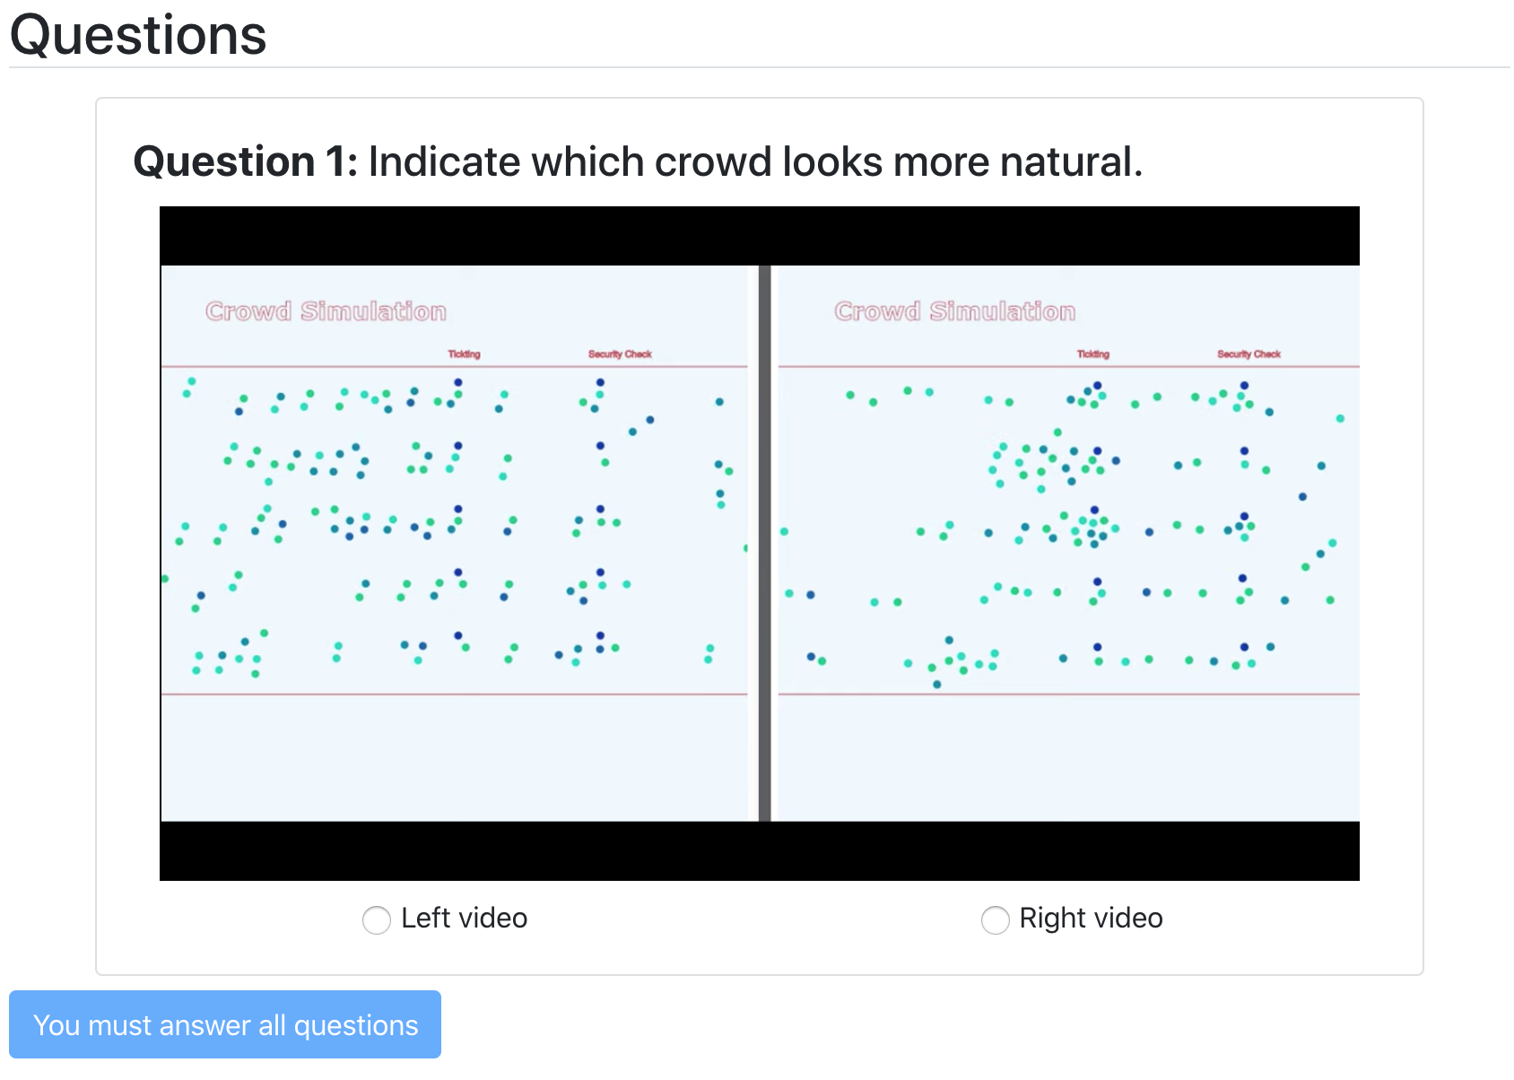

image: screen shot of survey interface

**8 Simulation Results:**

Based on the observation, some agents walk in pair. Agents do pair walking from the start position to end position. The pair walking behavior also includes waiting behavior. For instance, once leader agent finished its check, instead of thoughtlessly moving forward, it will wait in front until its partner finished its check.

Once agents are generated from their start positions. They move forward the closest checking spots and do security check. The upcoming agents in the scene which waiting for check start to form waiting lines. In the simulation, 4 waiting lines have been formed, each row in waiting line contains at most 2 agents. Agents in pair relationship also keep the pair status in the line.

During the waiting process, anxiety degree of each agent in the waiting line could represent desire of line changing. Based on the observation, once the anxiety degree is maximum and there are other shorter waiting lines nearby, agents leave its current line and line up at the shorter one. The line switching behavior happens to both individual agent and pair agents.

**9 Conclusion and Future Work**

In terms of future work, the application could only allow two agents walk in pair. However, in reality, I could always see group contains more than 3 people could also maintain the side by side walking. In this project, I present an approach allows agents do the complex queue up behavior such as forming waiting line, switching between lines and passing through certain gates. However, the waiting line is a straight line. Further, I will look for a way to allow waiting line to adjust its shape bases on the specific obstacle such as fence.

**10 Acknowledgements**

I would first like to thank NSF Grant #1718139. Also, I would like to thank my project advisor Dr. Brian Ricks of the Computer Science Department at the University of Nebraska Omaha. I can always find help from him when I have question about my research or writing. I would also like to thank Dr. Robin Gandhi and Dr. Hassan Farhat for serving on my project committees. It is a great honor to present my project to them and gather feedback from them. Finally, I would like to thank the support from my family and friends. The help from them is immeasurable through my studies and life.

**11 References**

[1] Reynolds, C.: Steering behaviors for autonomous characters. In: GDC, pp.763–782(1999) 10

[2] Baig, Mirza Waqar, et al. "Realistic modeling of agents in crowd simulations." 2014 5th International Conference on Intelligent Systems, Modelling and Simulation. IEEE, 2014.

[3] Oliva, Carmine, and Hannes Högni Vilhjálmsson. "Prediction in social path following." Proceedings of the seventh international conference on motion in games. ACM, 2014.

[4] Popelová, M., Bída, M., Brom, C., Gemrot, J., & Tomek, J. (2011, November). When a couple goes together: walk along steering. In International Conference on Motion in Games (pp. 278-289). Springer, Berlin, Heidelberg.

[5] Wong, Sai-Keung, Yi-Hung Chou, and Hsiang-Yu Yang. "A framework for simulating agent-based cooperative tasks in crowd simulation." Proceedings of the ACM SIGGRAPH Symposium on Interactive 3D Graphics and Games. ACM, 2018.

[6] Godoy, Julio, et al. "Online learning for multi-agent local navigation." CAVE Workshop at AAMAS. sn, 2013.

[7] Ref: http://masagroup.github.io/recastdetour/index.html